Developing a Cave Tourism Destination

- Road Access

The development of Gua Petruk as a tourism destination presents three major challenge, all concerned with access. The first is the road access to the site, and the need for a Gombong tourist road circuit already discussed above. The second is the walking route to the cave itself and the third is the necessary pathway through the cave. These will each be discussed and recommendations presented below.

The common form of a circuit route comprises a complementary series of attractions that can all be accessed from a well-developed road circuit. This circuit will then be publicised by

- leaflets, each with a map and a list of attractions
- a distinctive logo and signage system to mark the route and to welcome visitors to each attraction
- each attraction promoting the others along the circuit

In this example, the various attractions should highlight both the environmental values of the plateau and facets of the local culture and local industries of interest. Visitors should be able to feel that by following the circuit, they have come to understand the diversity of both the environment and the culture.

The road should be further supported by a cycle track system, parallel to the road but separated from it.

7. Arrival and Welcome

Commencing with the arrival at the site, the current forecourt is relatively pleasant, but can be improved. But, in particular, it must first be made clear where visitors should go to arrange a tour, have a snack before their cave visit, go to a toilet, etc. Signage should be minimal and only deal with what is essential, as this is to be a nature-based experience, not commercialized amusement.

Buildings associated with the forecourt should be only:

- Toilets and restrooms for visitors
- A prayer room
- Kiosk and other refreshments
- Craft and souvenir shop
- Staff Office and rest area

- Visitor Centre with ticket sales, information area and equipment store

Most importantly, a staff member should walk out to greet people and personally welcome them to the site. As is customary, staff should be recognized by their uniform and should wear a simple name badge (with their preferred name for the public in large clear lettering). But the uniform should not be the commonplace formal (almost militaristic) garb which one sees worn by most officials. It should be simple, but symbolize the local culture in some way.

Visitors should then be directed to the visitor centre which should be a simple structure with large windows so it is bright and well lit with natural illumination. Posters or other displays (but not specimens from the cave or elsewhere) should provide a first orientation to the site, and some basic information about the cave. A guide should be on duty in the visitor centre at all times to answer questions and provide tour information

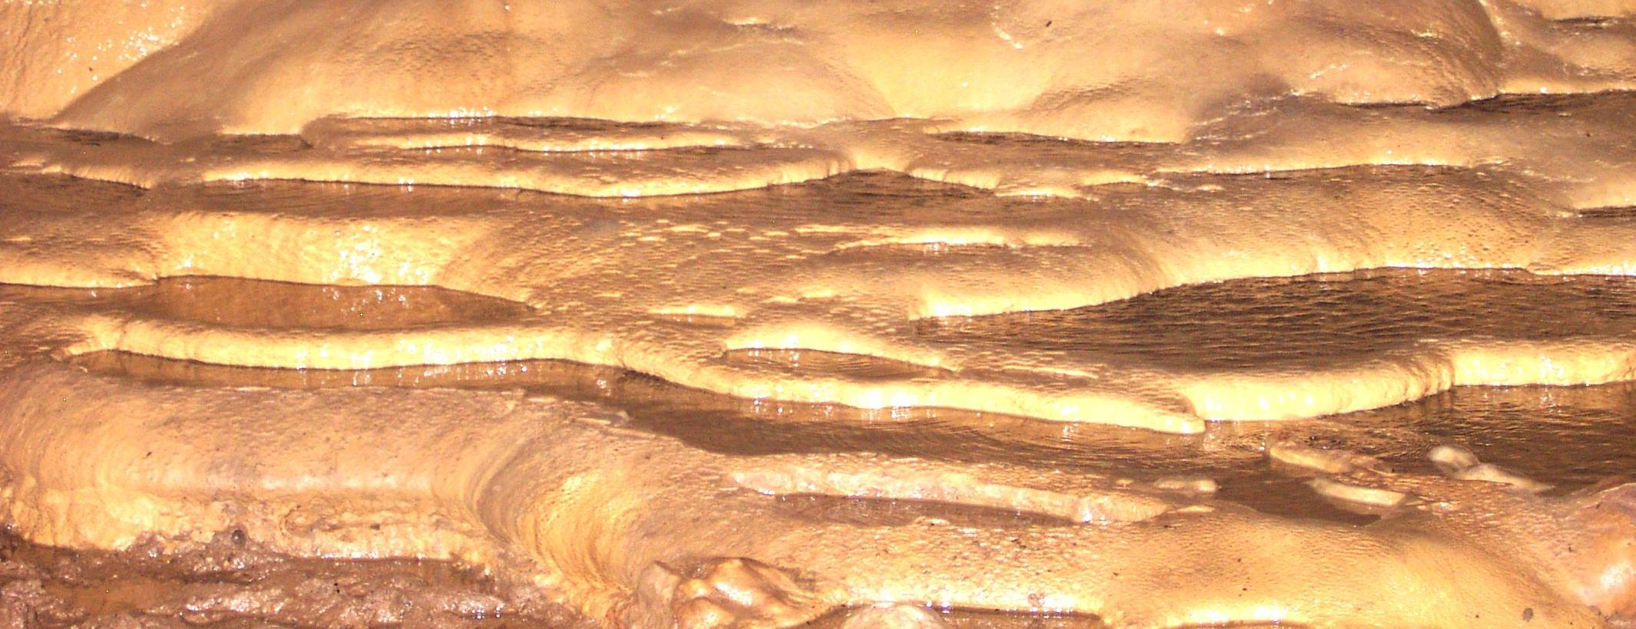
Photograph Hamilton-Smith

8. Proposals for Cave Development

The readily accessible section of Gua Petruk is a semi-horizontal tunnel with several sections at a higher level, and a stream outflow along the main tunnel. The shape of the cave is largely joint-controlled. I do not have a survey plan that depicts the longitudinal section of the cave, but it spears to have been shaped by the bedding planes. The original phreatic form of the cave has been modified by the vadose action of the river. There has only been limited exploration of the water-filled or other upstream sectors of the cave, but the volume of water suggests that the system may well be an extensive one.

Of course, the cave is named after a famous puppet-play character. Although the speleothem that led to this name is not readily accessible, guides should be able to display Petruk at the visitor centre, and tell visitors about his role in the puppet theatre. If residents make puppets, then Petruk might well be on sale at the craft shop.

The cave has a relatively important biodiversity. Frogs are common in the twilight zone and one snake was seen swimming along the river (probably living in the cave to feed on bats). There are at least two species of bats, the most numerous being a small Hipposideros sp. Large cave crickets (Rhapidiophoridae) are relatively common on the floors. The 2003 French expedition collected specimens of whip-scorpions, spiders, Schizomids, isopods, millipedes, snails and springtails. Further investigation of the fauna is obviously warranted.

It is also clear that the cave once housed a very much larger population of bats. There is extensive erosion and staining of the cave roof in both Gua Windu and a newly recorded passageway. The extent of this suggests that the free-tailed bat, Tadarida plicata, probably used these sites. Its disappearance is probably related to extensive use of insecticides.

The objectives of the development must first be agreed as they provide the basis for decision-making. For example, they might read:

To provide a range of visitor experiences which:

Are enjoyable and of high aesthetic quality

Develop positive values and behavior in relation to the environment

Assist people to develop their understanding of karst processes

Offer minimal risk of any kind

New infrastructure must commence with an easy access path to the cave entrance. This should be such as to provide an interesting walk through the forest, including rest stops with seating at points of special interest. The toilet near the cave should be demolished and replaced with a modern and easy-to-clean facility. Visitors would then walk with a guide through the main pathway (details below). Two or more off-track routes could also be made available to appropriate and interested groups.

